Social Emotional Learning (SEL): A Guide for Leaders in a Blended Environment

To access links remotely, click Control (ctrl) and the linked words in blue at the same time.

Permissions Information
Materials and content used and referenced in this user guide were created with permission to adapt and use granted by the Collaborative for Academic, Social, and Emotional Learning (CASEL), (www.casel.org).

Table of Contents
5 SEL Competencies 2
Self-Awareness 2
Self-Management 2
Social Awareness 3
Relationship Skills 3
Responsible Decision-Making Skills 3
The Classroom Context 4
Top 3 Supportive Classroom Practices 4
Lesson Planning Considerations 4
Additional SEL Resources 5
Curriculum 5
Teaching and Learning 5
Relationship Building 5
Educator & Staff Wellness 5
Schoolwide Implementation 5

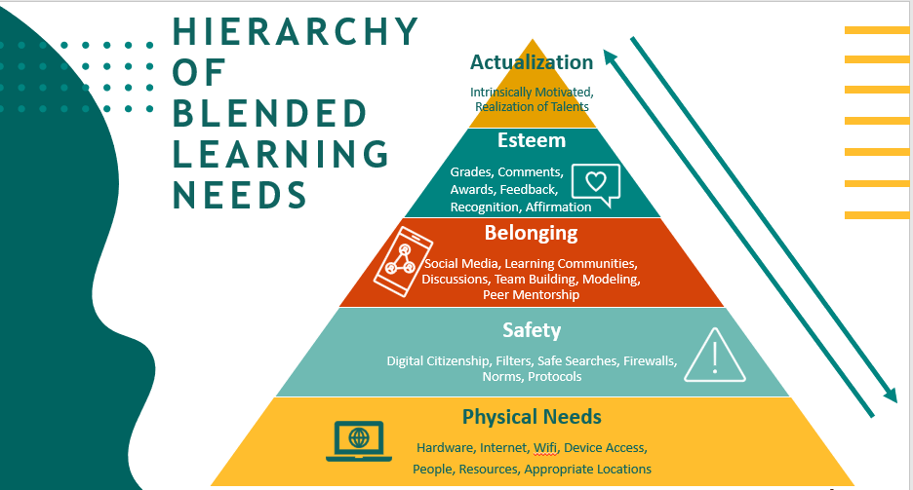

5 SEL Competencies
Self-Awareness  - Identifying emotions  - Social and cultural identity  - Recognizing strengths  - Growth mindset  - Self-efficacy  - Examining bias  - Sense of Purpose | Strategy Examples  - Take opportunities to connect lessons back to real life experiences.  - Help students self-evaluate their strengths and areas for growth.  - Increase metacognition (the ability to think about your thinking) through learning journals.  - Practice mindfulness meditation. | Blended eLMS Usage  - Polls, Wellness Check-Ins, & Checks for Understanding  - Videos and assignments related to identity, culture, and language  - Videos and learning journals using metacognition  - Choice boards
Self-Management  - Regulation of emotions  - Impulse control  - Stress management  - Self-discipline and motivation  - Perseverance  - Goal setting  - Organizational skills  - Initiative and agency | Strategy Examples  - Provide flexible seating and peace spaces.  - Create a system that allows students to monitor, observe, and record their academic behaviors and emotions.  - Time management logs  - Checklists & rubrics  - Rating scales  - Contracts or Agreements  - Allow time for students to reflect on goals.  - Fist to Five (Between You and Me) | Blended eLMS Usage  - Choice boards  - Agendas  - Student planner  - Resource folders  - Posted objectives  - Daily task list  - Timelines  - Goal setting & check-ins  - Flexible seating  - Checklists & rubrics  - Contracts & agreements

Social Awareness  - Perspective-taking  - Empathy and compassion  - Expressing gratitude  - Appreciating diversity  - Identifying social norms and demands  - Sense of belonging | Strategy Examples  - Create shared classroom norms.  - Engage families in learning.  - Model and practice active listening skills.  - Use the Jigsaw strategy during instruction.  - Create opportunities for collaboration. | Blended eLMS Usage  - Video conferencing  - Posting comments  - Posting work, attachments, photos, GIFs, etc.  - Small group feature  - Group projects  - Discussion boards  - Collaborative documents  - Exploration of digital museums and historical sites  - Discussions/videos with family & community
\

Relationship Skills  - Communication  - Cultural competence  - Building relationships  - Teamwork and working cooperatively  - Resolving conflicts  - Helping/seeking help  - Leadership  - Standing up for the rights of others | Strategy Examples  - Model conflict management skills through explicit mini lessons.  - Use inclusion and closure activities.  - Use class buddies/clock partners.  - Think, Ink, Pair, Share. | Blended eLMS Usage  - Video conferencing  - Posting comments  - Posting work, attachments, photos, GIFs, etc.  - Small group feature  - Group projects  - Discussion boards  - Collaborative documents  - Exploration of digital museums and historical sites  - Discussions/videos with family & community
Responsible Decision-Making Skills  - Demonstrating curiosity and open mindedness  - Identifying and solving problems  - Analyzing situations and consequences  - Ethical responsibility  - Reflecting on one’s role to promote individual and collective well-being | Strategy Examples  - Embed scenarios that present problems or decisions into instruction.  - Provide academic problems with multiple solutions.  - Model and practice decision making with pre-designed lessons and/or current classroom issues.  - Identify the problem  - Gather information  - Brainstorm solutions  - Identify consequences  - Make a choice & take action  - Allow productive struggle. | Blended eLMS Usage  - Video of class norms and expectations sent to families to view with learners  - Posted daily tasks and timelines  - Posted agenda  - Student planner

The Classroom Context

Top 3 Supportive Classroom Practices
Check out the CASEL Playbook for more ideas and how-tos

Inclusion Activities
- Smile warmly and greet each person by their preferred name
- Whole-group greeting activities (with voluntary participation)
- Morning circles/meetings
- Interactive “do-nows,” such as peer-to-peer homework help

Engagement Strategies (Interactive & Reflective)
- Think, Ink, Pair, Share (silent time to reflect; time to write; partner discussions; close with a group share out)
- Clock Partners (prearrange partners for quickly pairing up for reflection and discussion)
- Private think-time (facilitator wait-time)
- Mindful Minute Brain Break (a calming activity, promoting focus and readiness to learn

Closure Activities
- One-Minute Accolade
- Something I learned today…
- I am curious about…
- I am looking forward to tomorrow because…
- Suit Yourself
- Something I’ll do as a result of this learning is…
- Something I still question…
- Something that still concerns me...
Used with permission from CASEL©, 2013

Lesson Planning Considerations
- Academic and SEL learning objectives
- Open-ended questions
- Cooperative structures
- Collaborative learning tasks
- Student Voice & Choice
- Cultural responsiveness
- Reflection
SEL Integrated Sample Lesson Plans

Additional SEL Resources

Curriculum
List of SEL programs with filtering for your needs

Teaching and Learning
Remote Resources
Sample Teaching Activities
SEL Self-Reflection Prompts for Students
SEL Activities & Brain Games (by grade level)

Relationship Building
Building Relationships During COVID-19
Five Minute Chats

Educator & Staff Wellness
Educator Self-Care Assessment and Reflection Tool
Self-Care Circles

Schoolwide Implementation
Rubrics, planners, protocols, and surveys for Schoolwide Implementation

Permissions Information
Materials and content used and referenced in this user guide were created with permission to adapt and use granted by the Collaborative for Academic, Social, and Emotional Learning (CASEL), (www.casel.org).

